SQL QUERIES WITH RESULTS
1.
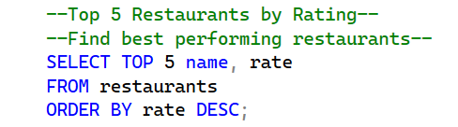
OUTPUT:
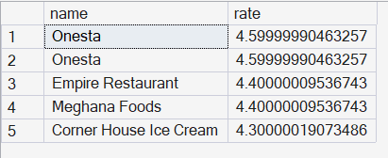
2.
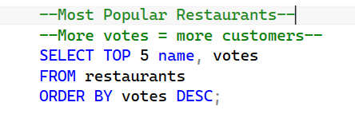
OUTPUT:
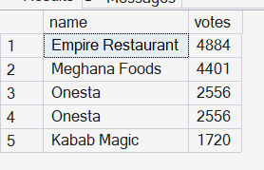
3.
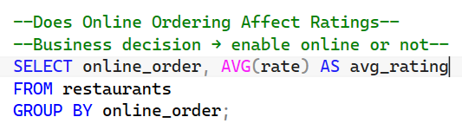
OUTPUT:

4.
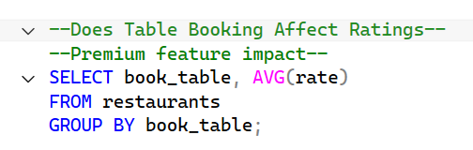
OUTPUT:
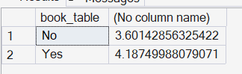
5.
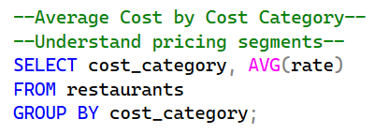
OUTPUT:
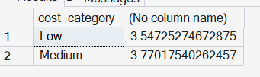
6.
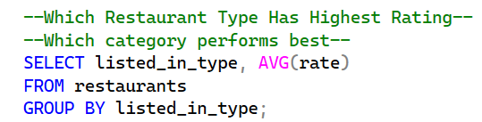
OUTPUT:
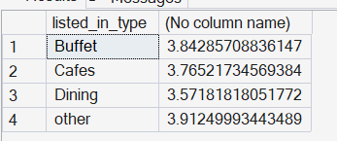
7.
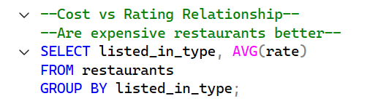
OUTPUT:
